

**University of Barishal**

**Project Report on**

**“****Foreign Exchange Operation of Government Bank”**

**Submitted To:**

**Dr. Tania Islam**

Assistant Professor

Department of Computer Science and Engineering, University of Barishal.

**Submitted By:**

Md. Atiqur Rahman

Batch: 65; Roll: 25

EDGE: BU-CSE Digital Skills Training

Computer Fundamentals & Office Application

**Date of Submission:**

# Report Title

**Foreign Exchange Operation of Government Bank**

Table of Contents

Report Title 2

Chapter-1 4

Introduction 4

1.2: Objectives of the study: 5

1.3: Methodology of the study: 5

1.4: Sources of data: 6

Primary Data: 6

Secondary Data: 6

1.5: Management Hierarchy of Sonali Bank PLC: 7

1.6: Orientation of Sonali Bank PLC Foreign Exchange Corporate Branch: 8

1.7: Business Position at a Glance 9

1.8: Graphical Presentation 11

Chapter-2 13

Foreign Exchange Business 13

2.1 Introduction: 13

2.2 Foreign Trade Finance: 14

2.3: RECOMMENDATIONS: 14

4: Conclusion: 16

Reference: 17

## Chapter-1

## Introduction

**1.1 Authorization of the study:**

Banking is one of the most important sectors for country’s wealth building activities. Commercial banks are certainly profit-making Financial Institutions. These institutions play great role in the money market of every economy.

Due to globalization, technological innovation and deregulation the banking system all over the world has been changing rapidly. Now a day’s banks have to compete in the market place not only with local institutions but also with foreign financial institutions.

Sonali bank PLC is one of the leading commercial banks in Bangladesh. Its pioneer role in handling foreign trade and foreign exchange transactions ever before independence of the country still remains unchallenged. With wide network of branches at home and also a large number of correspondent banks worldwide it is singularly handling the largest volume of export-import business including homebound remittances.

For this reason, Foreign Exchange of Sonali Bank PLC is very much essential. But now a day the banking sector of Bangladesh is suffering from the diseases of default culture which is the consequence or result of bad performance of most of the banks. Sonali Bank PLC is playing an important role toward the growth and economic development of Bangladesh.

As a part of fulfilling the requirements of completing the degree of BBA I was placed in the Foreign Exchange Division of Sonali Bank PLC under the internship program of the Department of Accounting and Information Systems, University of Barishal. During the three months of internship in the said division, beside regular job orientation, the topic of study that was officially assigned to me was “Foreign Exchange Operation of Sonali Bank PLC”.

### 1.2: Objectives of the study:

The general objective of the study is to gather practical knowledge regarding banking system and operation. The practical orientation gives us a chance to co-ordinate out theoretical knowledge with the practical experience. This consists the following:

* To get an overall idea about the foreign exchange Business of Sonali Bank PLC.
* To apply theoretical knowledge in the practical field.
* To describe the organizational structure, management, background, functions and objectives of the bank and its contribution to the national economy.
* To achieve overall understanding of Sonali Bank PLC.
* To analyze the financing systems of the bank to find out any contributing field.
* To examine the profitability and productivity of the bank.
* To acquire knowledge about the everyday banking operation of Sonali Bank PLC.
* To understand the real management situation and try to recommend for improving existing problems.

### 1.3: Methodology of the study:

The report is prepared on the basic of foreign Exchange Management of Sonali Bank PLC. To conduct the overall study, at first, I explored the sources of primary and Secondary information and data. Different files of the department and statement prepared by FED helped me to prepare this report. I have interviewed the SB officials for getting more information. To present numerical data, I used the Annual Report of 2023 and monthly statement of November 2020 of Sonali Bank PLC of Head office, Local branch. For preparing this report I have used some graphical representation to find out different types of analytical and interpretation.

### 1.4: Sources of data:

As mentioned earlier, mainly primary data has been used. Sometimes the customers gave some important information regarding the services of the Bank:

### Primary Data:

* Official records of Sonali Bank Limited (SB PLC).
* Face to face conversation with the officer.
* Direct observation.
* Face to face conversation with the client.
* Expert opinion.

### Secondary Data:

Monthly Statement of SB PLC.

* Annual Report of SB PLC.
* Working Papers.
* Official Files.
* Selected books.
* Other manual information.
* Websites.
* Various publications on the Bank.
* Newspaper reports in this concern.

### 1.5: Management Hierarchy of Sonali Bank PLC:

**Board of Directors**

**MD & CEO**

**Deputy Managing Directors**

**General Managers**

At Field GM Office -8

**General Managers**

At Zone-2

**General Managers**

At Head Office & Local Office-8

**DGMs** (At Divisional Head of Head Office)

**DGMs** (At Field Offices)

**AGMs** (At Field Offices)

**AGMs** (At Head Office)

**Other Executives** (SEO, SE, SO, Officer at Field Offices)

**Other Executives** (SEO, SE, SO, Officer at Head Office)

**Other Staffs** (At Field Offices)

**Other Staffs** (At Head Office)

### 1.6: Orientation of Sonali Bank PLC Foreign Exchange Corporate Branch:

Sonali Bank Limited Foreign Exchange Corporate Branch is located in 11/2 Toynbee Circular Road, Dhaka-1000. The corporate branch does all the banking functions and I worked few days in Foreign Exchange Corporate Branch of Sonali Bank Limited. It is a big branch because its total employees are about 147 and it performs all the four basic functions. The head of the department is Deputy General Manager and the lower rank is officer. The positional hierarchy of foreign exchange Corporate Branch of Sonali Bank PLC is given bellow:

**Deputy General Manager**

**Assistant General Manager (2)**

**Senior Principal Officer (6)**

**Principal Officer (9)**

**Senior Officer (12)**

**Officer (30)**

**Staff (87)**

### 1.7: Business Position at a Glance

(Taka in Crore)

|  |  |  |  |  |  |
| --- | --- | --- | --- | --- | --- |
| **Sl.** | **Particulars** | **Position as on Sept., 2022** | **Position as on Dec. 31, 2022** | **Target 2023** | **Position as on Sept., 2023** |
| 1 | 2 | 3 | 4 | 5 | 6 |
| 01. | Deposit | 29656.85 | 32899.72 | 35250.00 | 33395.94 |
| 02. | Loans & Advances | 24451.58 | 20634.76 | 21515.00 | 22823.69 |
| 03 | Classified Loans & Advances | 7073.32 | 92.1.35 | - | 8094.29 |
| 04. | % of Classified Loans to Total Advances | 28.93% | 44.59% | - | 35.46% |
| 05. | Recovery of Classified Loans | 591.28 | 1007.55 | 2747.12 | 1025.41 |
| 06. | Total Provision Required | 4669.31 | 6032.41 | - | 5708.51 |
| 07 | Total Provision Maintained | 4123.54 | 6075.91 | - | 5913.18 |
| 08. | Total Provision Surplus/Shortfall | -545.77 | 43.50 | - | 204.67 |
| 09 | Capital Required | 1232.06 | 1630.41 | - | 1844.35 |
| 10. | Capital Maintained | -4624.42 | 2034.22 | - | 2232.54 |
| 11 | Capital Shortfall/Surplus | -5856.48 | 403.81 | - | 388.19 |
| 12 | 15% of Capital | - | 305.13 | - | 334.88 |
| 13 | Import | 5384.30 | 7649.68 | 8415.00 | 12598.15 |
| 14 | Export | 5901.26 | 7804.59 | 9267.13 | 6413.44 |
| 15 | Foreign Remittance (Inward) | 6826.25 | 9217.83 | 9038.00 | 7819.82 |
| 16 | Total no. of Branches (Excl. Foreign Br.) | 1181 | 1181 | - | 1179 |
| 17. | Cost of Deposit (%) | 5.11% | 4.80% | - | 4.59% |
| 18. | Cost of Fund (%) | 7.00% | 6.74% | - | 6.47% |
| 19. | Total Income | 1720.95 | 2571.02 | - | 1868.00 |
| 20. | Total Expenses | 1520.08 | 2022.88 | - | 1557.00 |
| 21. | Profit/Loss (Operating Profit) | 200.87 | 560.14 | 1000.00 | 311.00 |

1.8: Graphical Presentation:

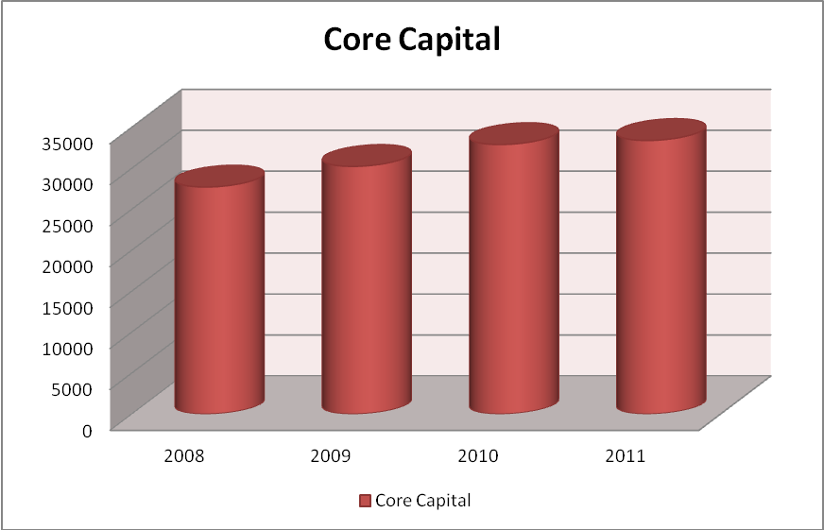

2020 2021 2022 2023

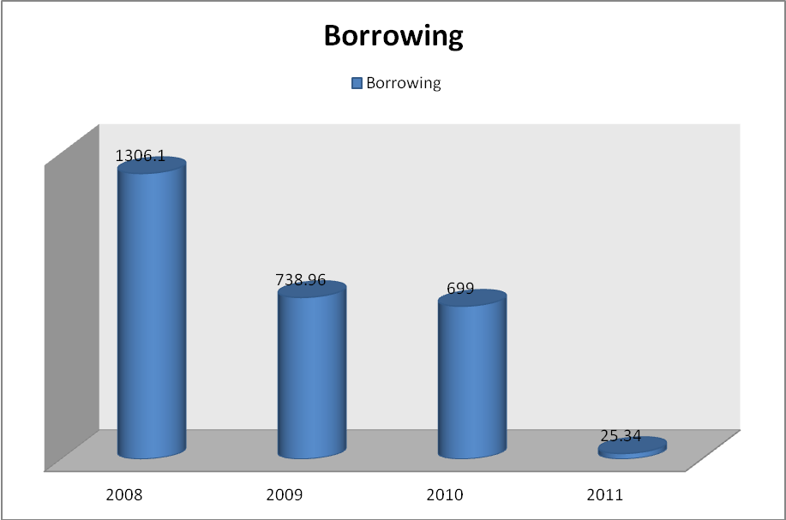

2020 2021 2022 2023

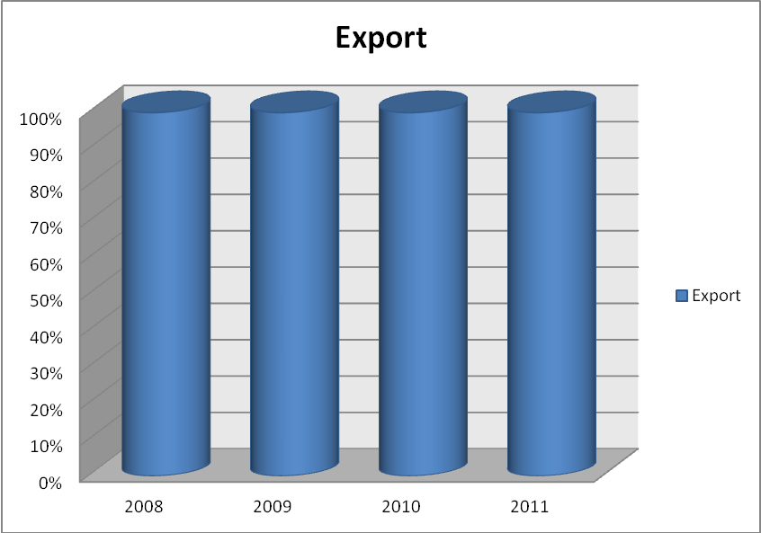

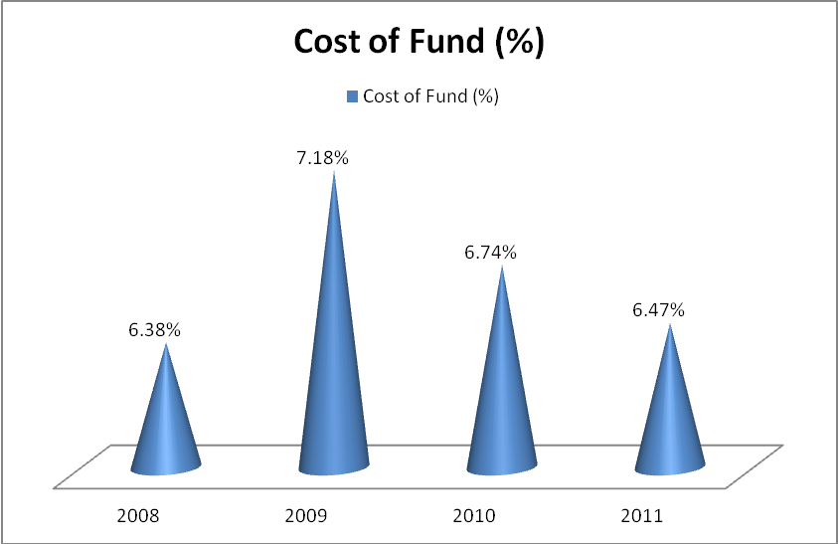

2020 2021 2022 2023

# Chapter-2

# Foreign Exchange Business

### 2.1 Introduction:

Commercially banks deals with both internal and foreign correspondence. The foreign correspondences are conducted through foreign currency and the department dealing with these businesses is called foreign exchange department.

Sonali Bank's expertise in International Banking has a record of in-house growth over more than half a century. Its pioneer role in handling foreign trade and foreign exchange transactions ever before independence of the country still remains unchallenged. With wide network of branches at home and also a large number of correspondent banks worldwide it is singularly handling the largest volume of export-import business including homebound remittances.

Foreign Exchange deals with the means &methods by which rights to wealth in one country's currency are converted into those of another currency. It is a part of economic science of foreign trade. By the same view, it covers the methods used for conversion, the forms in which such conversions take place and causes which render these conversions necessary.

In Bangladesh, we have the unit of money is 'Taka' for domestic transaction; also have other obligations by exchanging foreign currencies. To meet-up the obligation that arise import of goods *&* services from other countries, other foreign necessity, that part of the economic science, which deals with the conversion of domestic currency into foreign currency for the purpose of setting international obligations, is called Foreign Exchange.

Every country has certain natural advantages in producing certain commodities while they have some natural disadvantages as well as in other. As a result, we find that some countries need to import certain commodities while others necessity to export their surpluses. There are three types of modes of foreign exchange market, which are as follows:

* **Export Finance**
* **Import Finance**
* **Foreign Remittance**

### 2.2 Foreign Trade Finance:

The total foreign exchange business of the Bank for the year 2023 was Tk. 1660.92 crore as against Tk. 16054.18 crore in 2022 showing an increase of 3.41%.

Comparative Position of foreign exchange business for the year 2022& 2023 are stated below: -

(Tk. in Crore)

|  |  |  |  |
| --- | --- | --- | --- |
| **SI. No.** | **Particulars** | **2022** | **2023** |
| 1. | Total Import | 5294.04 | 5257.74 |
| 2. | Total Export | 4150.31 | 4790.65 |
| 3. | Inward Remittance (Including WES) | 6069.67 | 5766.15 |
| 4. | Outward Remittance (Including WES) | 540.16 | 787.38 |
|  | Total | 16054.18 | 16601.92 |

### 2.3: RECOMMENDATIONS:

Since Sonali Bank is the leading nationalized commercial Bank of Bangladesh, it must have to remove its limitation in banking service. In my study I have recognized several weakness present states of Banking service (Mainly cash credit) and my recommendation are given below:

1. Process and procedures of lending should be liberalized keeping in view the problems and constraints faced by the borrower or intending borrowers.
2. Advance officer of the branch should be provided with training facilities and necessary incentives to ensure proper follow-up and timely recovery of loan even separate board should be formed to carry on project feasibility study which may strengthen the better utilization of the advances, better returns to the borrowers as well as to this branch also.
3. Necessary guidance is to be imparted to the ways and means lending to self-reliance, this may be ensured by way of enhancing the better communication with the intending borrowers.
4. Better publicity, seminar and workshop on loan may brighten the situation highlighting the needs and problems of the people or borrower.
5. Public sector banks should be required and induced to expand their branch network in rural areas.
6. Rural finance programs should be launched by the public sector Bank at their earliest convenience.
7. Deposit condition of this Branch is not satisfactory. Deposit is the blood of a bank. Thus, deposit collection of this branch should be improved. The branch should take necessary actions and introduce various schemes to raise deposit.
8. Orientation training of the borrowers may change their mental outlook, which needs to be emphasized for the better benefits of the borrowers and the bank.
9. Loan disbursement performance of this branch is not good, a task force should be formed to find out profitable and less risky project for proper loan disbursement. It will help the bank to recover loan timely and maintain a stable pattern of inflow.
10. Disbursement of loans, purpose of loans, recovery rates, efficiency level etc, need to studies implication. Although an attempt is made to focus the variation and identify the related factors but due to reluctance the same could not be done.
11. Monitoring and supervising are the precondition of better loan recovery performance of the bank. This bank should improve its monitoring and supervision activities to increase loan recovery performance.
12. Virtually for the interest of the borrower and intending borrowers more fund should be shifted to this branch considering their needs and requirement.
13. Steps should be taken to solve the problems of the borrower which utilizing their loan and advance.

### 4: Conclusion:

Sonali Bank is the largest commercial bank in the country. It has 1200 branches including home and abroad. As Sonali Bank a state-owned bank, it has many limitations in policy making. But it performs many tasks to government employees. It serves as a third party to the government. Government also takes loan from this bank. Bangladesh bank implements many policies by the help of this bank. It acts as a clearing house where Bangladesh bank has no branch. It provides salary to the government officials, collects gas bill, was a bill etc. It also performs general banking, loan and credit banking; foreign exchange operation etc. at *Head office, local Branch, Motijheel* is one of the branches which perform all the function mentioned above. It also sells the national savings certificate. My internship is only for 72 days which is very less time to know the all function of a bank. I tried my best to know about the bank, its different functions, and its work environment. I also compare the difference between theoretical and practical knowledge. I gather some experience of the job. Sonali Bank has to replace the traditional banking by the E-banking facilities. I also suggest appointing young, energetic person as staff member.

### Reference:

1. Annual Report of Sonali Bank.
2. Bangladesh Bank Bulletin July September, 1999.
3. Bank PARIKRAMA; Volume XIX, Nos. 1 & 2 March & June 1994.
4. Bank PARIKRAMA; Volume XXI, Nos. 1 & 2 March & June 1996.
5. “An Evaluation of Financial Reporting of the Commercial Banks in Bangladesh.” MD. KAZI SAIDUL ISLAM.
6. “Performance Evaluation of the National Commercial Banks in Bangladesh: A Comparative Study S.A. SHAKOOR.
7. “Institutional Financing for the Disadvantaged Groups- A case study of Rajshahi District, Bangladesh.” SAJAL KUMAR MUKHERJEE, Chairman, Department of Finance and Banking.